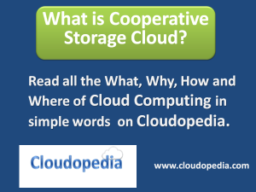
Cooperative storage cloud is a type of cloud storage service model that delivers cloud storage by storing and distributing data across connected and subscribed clients and nodes. Cooperative storage cloud is a peer to peer storage cloud that enables storage of data on remote and distinct participants that pool in with some or more of their storage capacity to deliver a unified cloud storage solution.

How does Cooperative Storage Cloud works?
Cooperative storage cloud is mainly implements, peer to peer computing architecture in connecting and, organizing remote peers into a collective storage pool. Typically, Cooperative Cloud Storage is delivered by a cloud storage service provider. They provide subscribers with P2P software that manages the storage and retrieval of data from the pool.
Each subscribers installs the P2P storage cloud software on their computers / servers and specifies the storage capacity they can allocate to the pool. The cooperative storage cloud services groups / combines / pools all the storage capacity from the subscribers into a one large virtual storage capacity. This collective virtual storage space is provisioned / shared among all subscribers.
The key principle behind operations of cooperative storage cloud is that not all the subscribers will be using large or heavier proportion of storage capacity. So, there will always be a possibility that the collective storage capacity from all subscribers will be enough for them.

How and Where Cooperative Storage Cloud is used?
Cooperative storage cloud has multiple personal and business uses.
- Organizations can create a large internal storage cloud pool
- Store a backup instance of a file on other computers ( subscriber’s)
Create a virtual storage infrastructure without any storage hardware

