What is a Native Cloud Application?
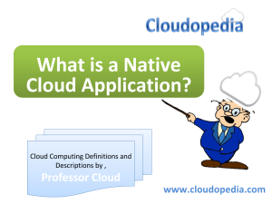
What is a Native Cloud Application?

Definition of Native Cloud Application
Native cloud application is referred to any application that is specifically designed and developed for cloud computing and virtualization environments. It is developed and deployed in such a way that it extracts the most out of underlying cloud infrastructure or to deliver the required cloud feature (such as connecting two clouds).

Brief Description of Native Cloud Application

Native cloud applications are primarily developed in par with the cloud computing architecture. It is coded in a way to harness the back-end processing, resource scalability, virtual networking, virtualization and other cloud services. Native cloud applications generally massively parallel that performs large amount of cloud based and/or remote user requests. are considered to exhibit below mentioned characteristics. It uses native Cloud API’s to utilize the underlying compute, memory, networking and cloud services. Moreover, it also has the ability to be ported / deployed / used within different cloud computing architectures/ infrastructures/ providers.

